

**Scenario Based Questions**

**Topic: Java**

1. **Write a Java Program to iterate ArrayList using for-loop, while-loop, and advance for-loop to get the result as shown below:**

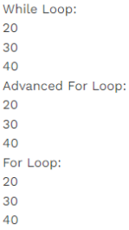

**Solution:**

**package** assignmentSolutions;

**import** java.util.*;

**public** **class** ArrayListSolution

{

**public** **static** **void** main(String[] args)

{

List<Integer> l1=**new** ArrayList();

l1.add(20);

l1.add(30);

l1.add(40);

System.***out***.println("While Loop:");

**int** n=0;

**while**(l1.size()>n)

{

System.***out***.println(l1.get(n));

n++;

}

System.***out***.println("Advanced For Loop:");

**for**(Integer j:l1)

{

System.***out***.println(j);

}

System.***out***.println("For Loop:");

**for**(**int** i=0;i<l1.size();i++)

{

System.***out***.println(l1.get(i));

}

}

}

**OUTPUT**

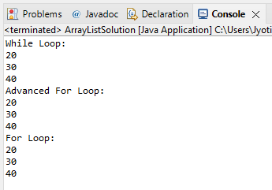

1. **create a doubly linked list and rotate it by n node to get the result as shown below:**

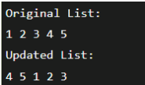

**Solution**

**package** assignmentSolutions;

**public** **class** DoublyLinkedList1

{

**static** **class** Node

{

**int** element;

Node pre;

Node next;

}

**static** Node *head* = **null**;

**static** **void** rotate( **int** n)

{

**if** (n == 0)

**return**;

Node current = *head*;

**int** count = 1;

**while** (count < n && current != **null**)

{

current = current.next;

count++;

}

**if** (current == **null**)

**return**;

Node nthNode = current;

**while** (current.next != **null**)

current = current.next;

current.next = *head*;

(*head*).pre = current;

*head* = nthNode.next;

(*head*).pre = **null**;

nthNode.next = **null**;

}

**static** **void** push(**int** new_data)

{

Node new_node = **new** Node();

new_node.element = new_data;

new_node.pre = **null**;

new_node.next = (*head*);

**if** ((*head*) != **null**)

(*head*).pre = new_node;

*head* = new_node;

}

**static** **void** displayList(Node node)

{

**while** (node != **null** && node.next != **null**)

{

System.***out***.print(node.element + " ");

node = node.next;

}

**if**(node != **null**)

System.***out***.print(node.element);

}

**public** **static** **void** main(String[] args)

{

*push*(5);

*push*(4);

*push*(3);

*push*(2);

*push*(1);

**int** n = 3;

System.***out***.println("Original List: ");

*displayList*(*head*);

*rotate*(n);

System.***out***.println();

System.***out***.println("Updated list ");

*displayList*(*head*);

}

}

**OUTPUT**

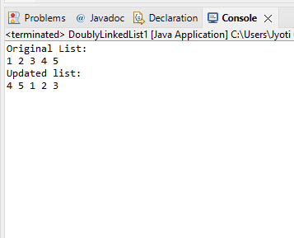

**Topic: SQL**

**3. At St. Xavier’s College, a faculty has the following data in My SQL in database named as Class**

**having table student related to Semester Examination.**

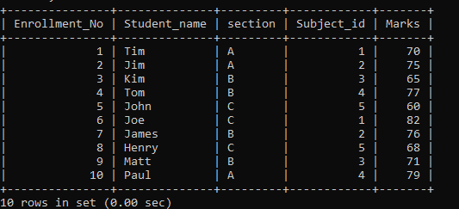

**Solution**

mysql> select section, Count(Marks) "as No. of Candidate greater than or equal to 75 marks" from student1

-> where Marks>=75

-> group by Section;

**OUTPUT**

